

**NUR SITI DAHLIA BINTI AB GHANI**

**S62584**

**BACHELOR OF SCIENCE COMPUTER (MOBILE COMPUTING)**

**LAB REPORT 3**

**Lab 3**

**Task 1 – JavaScript Function**

1. **Write a function to find the square of a given number**

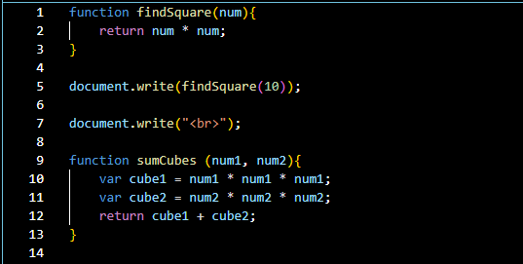

1. **Write a function to find sum of cubes of two numbers**
2. function sumCubes (num1, num2){
3. var cube1 = num1 * num1 * num1;
4. var cube2 = num2 * num2 * num2;
5. return cube1 + cube2;
6. }
7. document.write(sumCubes(4,6));

**3. Write a function to reverse a number**

[ Hint n =12345 output : 54321 ]

function reverseNumber (number){

    var result = 0;

    while (number != 0){

        result = result * 10 + number % 10;

        number = Math.floor(number/10);

    }

    return result;

}

document.write(reverseNumber(12345));

**4. Write a function to print all numbers between 1 and 100 which is divisible by given number z**

function divisibleNumber(z){

    for (var i = 1; i <= 100; i++){

        if (i % z == 0) {

            document.write(i);

        }

    }

}

divisibleNumber(50);

**Task 2 - JavaScript Recursion Function**

1. **Write a JavaScript function to find sum of digits of a number**
2. function sumDigit (value){
3. var sum = 0;
4. while (value){
5. sum += value % 10;
6. value = Math.floor(value/10);
7. }
8. document.write(sum);
9. }
10. sumDigit(309);

**2. Write a JavaScript program to compute x raise to the power y using recursion**

function power(x, y){

    if (y == 0){

        return 1;

    } else if (y < 0){

        return 1 / power(x, -y);

    } else {

        return x * power (x, y - 1);

    }

}

document.write(power(5, 5));

**Task 3 – JavaScript Object and Prototype**

1. **Write a JavaScript program to create object product,** 
   1. **Add the property Product Name, Quantity and price.**
   2. **Access all the properties and display them.**
2. var product = {
3. productName: 'NoteBook',
4. quantity: 15,
5. price: 19.99
6. };
7. document.write('<br>Product Name: ', product.productName);
8. document.write('<br>Quantity: ', product.quantity);
9. document.write('<br>Price: ', product.price);

**2. Write a JavaScript program to create object book**

* 1. **Add the property book name, author name**
  2. **Add the prototype property price.**
  3. **Display all the properties.**

1. function book(bookName, authorName) {
2. this.bookName = bookName;
3. this.authorName = authorName;
4. }
6. book.prototype.price = 89.99;
8. var book = new book('Phyton Programming ', 'Mohd');
10. document.write('<br>Book Name:', book.bookName);
11. document.write('<br>Author Name:', book.authorName);
12. document.write('<br>Price:', book.price);

**3. Write a JavaScript program to create Parent object employee**

**(Property: Employee Name, Employee Id, Salary) and Child object Manager (Property: Manager Name, Branch). Inherit all the properties of employee and display all the properties.**

function employee(empName, empId, salary){

    this.empName = empName;

    this.empId = empId;

    this.salary = salary;

}

function manager(empName, empId, salary, managerName, branch){

    employee.call(this, empName, empId, salary);

    this.managerName = managerName;

    this.branch = branch;

}

manager.prototype = Object.create(employee.prototype);

var manager1 = new manager('Nuha Nordin', 'S0001', 4500, 'Amir', 'Puchong');

document.write('<br> Employee Name: ' + manager1.empName +

'<br> Employee ID: ', manager1.empId +

'<br> Salary: ', manager1.salary +

'<br> Manager Name: ', manager1.managerName +

'<br> Branch: ', manager1.branch);

**Task 4 – Event Manager**

1. **Create a HTML page with <p> paragraph. Change the paragraph color according to the following mouse events** 
   1. **Onclick, yellow background**
   2. **ondblclick, blue background**
   3. **onmouseover , red background**
   4. **onmouseout, green background**
2. <!DOCTYPE html>
3. <html lang="en"><head>
4. <meta charset="UTF-8">
5. <meta http-equiv="X-UA-Compatible" content="IE=edge">
6. <meta name="viewport" content="width=device-width, initial-scale=1.0">
7. <title>Task 4 Lab Front End</title>
8. <style>
9. p {
10. width: 100%;
11. padding: 20px;
12. text-align: center;
13. font-weight: bold;
14. }
15. </style><script>
16. function changeColor(event) {
17. var paragraph = document.getElementById("myP");
18. switch (event.type) {
19. case "click":
20. paragraph.style.backgroundColor = "yellow";
21. break;
22. case "dblclick":
23. paragraph.style.backgroundColor = "blue";
24. break;
25. case "mouseover":
26. paragraph.style.backgroundColor = "red";
27. break;
28. case "mouseout":
29. paragraph.style.backgroundColor = "green";
30. break;
31. }
32. }
33. </script></head>
34. <body>
35. <p id="myP" onclick="changeColor(event)" ondblclick="changeColor(event)" onmouseover="changeColor(event)"
36. onmouseout="changeColor(event)">Hello world, This is Dahlia!</p>
37. </body>
38. </html>

**2. Create a HTML page with textfield. Show some effects on the textfield when the following events occurred:**

* 1. **Onchange**
  2. **Onfocus**
  3. **onblur**

<!DOCTYPE html>

<html lang="en">

<head>

    <meta charset="UTF-8">

    <meta http-equiv="X-UA-Compatible" content="IE=edge">

    <meta name="viewport" content="width=device-width, initial-scale=1.0">

    <title>TextField</title>

  <style>

    input {

      padding: 10px;

      width: 50%;

    }

  </style>

  <script>

    function applyEffect(event) {

      var textField = event.target;

      switch (event.type) {

        case "change":

          textField.style.backgroundColor = "lightblue";

          break;

        case "focus":

          textField.style.background = "yellow";

          break;

        case "blur":

          let x = document.getElementById("in");

          x.value = textField.value.toUpperCase();

          break;

      }

    }

  </script>

</head>

<body>

  <input type="text" id="in" onblur="applyEffect(event)" onchange="applyEffect(event)" onfocus="applyEffect(event)">

</body>

</html>

**Output:**

Question1:

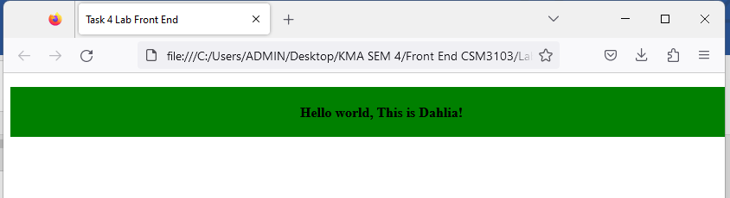

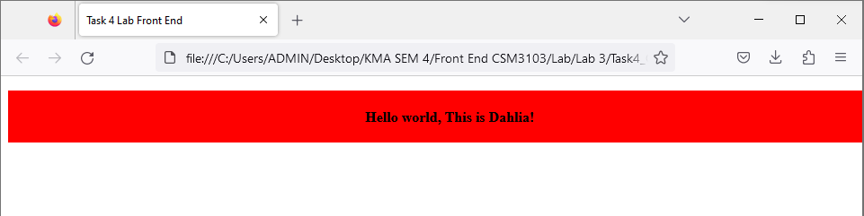

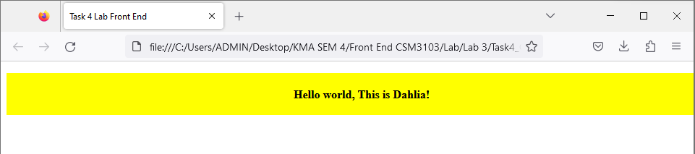

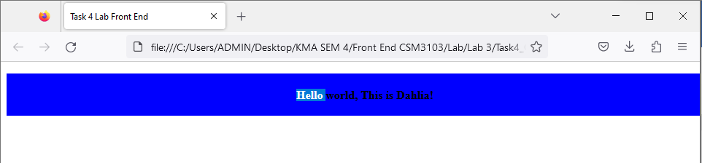

**Question2:**

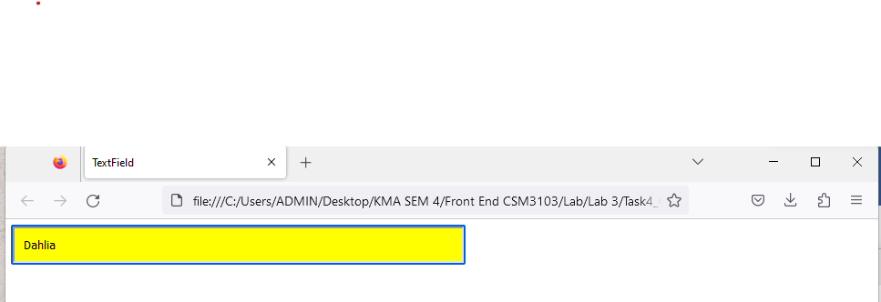

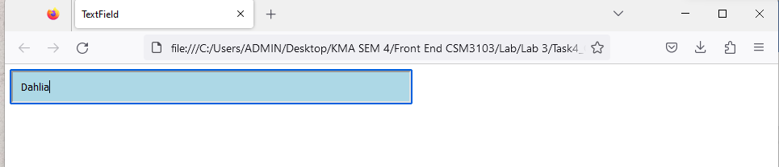

**Task 5**

**Given the following HTML table**

|  |  |  |  |
| --- | --- | --- | --- |
| **1** | **Ahmad Faisal** | **ahmadfaisal@gmail.com** | **0199088888** |
| **2.** | **Ismail Sabri** | **isabri@mail.com** | **0199076760** |
| **3** | **Fateh Yakin** | **ffateh@hotmail.com** | **0176067762** |

1. **Using javascript add the following record into table** 
   1. **Name: Mukhriz Jamil Asoka**
   2. **Email: mukriz@corp.jo**
   3. **Phone: 651181187223**
2. **Using javascript add the table header as follow:** 
   1. **#, Name, Email, Phone #**
3. **Using javascript, delete any row from table when clicked on that row**

***Task5.html***

<!DOCTYPE html>

<html lang="en">

<head>

    <meta charset="UTF-8">

    <meta http-equiv="X-UA-Compatible" content="IE=edge">

    <meta name="viewport" content="width=device-width, initial-scale=1.0">

    <title>Task 5 Front End </title>

  <style>

    table{

        border-collapse: collapse;

    }

    th,td{

        border: 1px solid black;

        padding: 8px;

    }

    </style>

    </head><head><body>

        <table id="myTable">

            <thead>

            </thead>

            <tbody>

                <tr>

                    <td>1.</td>

                    <td>Ahmad Faisal</td>

                    <td>ahmadFaisal@gmail.com</td>

                    <td>0199088888 </td>

                </tr>

                <tr>

                    <td>2.</td>

                    <td>Ismail Sabri</td>

                    <td>isabri@gmail.com</td>

                    <td>0199076760 </td>

                </tr>

                <tr>

                    <td>3.</td>

                    <td>Fateh Yakin</td>

                    <td>ffateh@gmail.com</td>

                    <td>0176067762 </td>

                </tr>

            </tbody>

        </table>

        <script src="Task5.js"></script>

    </body></head>

</html>

***Task5.js***

var newRow = document.createElement("tr");

var cell1 = document.createElement("td");

cell1.textContent = "4";

var cell2 = document.createElement("td");

cell2.textContent = "Mukhriz Jamil Asoka";

var cell3 = document.createElement("td");

cell3.textContent = "mukhriz@corp.jo";

var cell4 = document.createElement("td");

cell4.textContent = "651181187223";

newRow.appendChild(cell1);

newRow.appendChild(cell2);

newRow.appendChild(cell3);

newRow.appendChild(cell4);

table.appendChild(newRow);

var headerRow = document.createElement("tr");

var headerCell1 = document.createElement("th");

headerCell1.textContent = "#";

var headerCell2 = document.createElement("th");

headerCell2.textContent = "Name";

var headerCell3 = document.createElement("th");

headerCell3.textContent = "Email";

var headerCell4 = document.createElement("th");

headerCell4.textContent = "Phone #";

headerRow.appendChild(headerCell1);

headerRow.appendChild(headerCell2);

headerRow.appendChild(headerCell3);

headerRow.appendChild(headerCell4);

table.querySelector("thead").appendChild(headerRow);

var Rows = table.getElementByTagName("tr");

for(var i =0; i<rows.length; i++){

rows[i].addEventListener("click",function(){

    this.parentNode.removeChild(this);

});

}

**Output:**

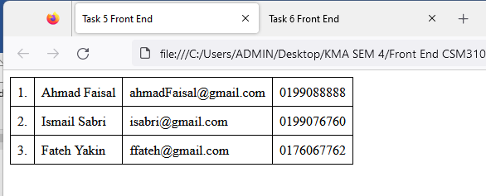

**Task 6**

**Write a JavaScript program to move two small squares inside one big square in a random manner. User should be able to start and stop this animation using button based events**

**Math.floor(Math.random() * Math.floor(max)) will give you a** **random number that is less than max value**

***Task6.html***

<!DOCTYPE html>

<html lang="en">

<head>

    <meta charset="UTF-8">

    <meta http-equiv="X-UA-Compatible" content="IE=edge">

    <meta name="viewport" content="width=device-width, initial-scale=1.0">

    <title>Task 6 Front End</title>

  <style>

    #bigSquare {

        position: relative;

        width: 400px;

        height: 400px;

        border: 2px solid black;

        margin-bottom: 20px;

    }

    .smallSquare{

        position: absolute;

        width:50px;

        height: 50px;

        background-color: pink;

    }

    </style></head>

    <body>

        <div id="bigSquare">

            <div id="smallSquare1" class="smallSquare"></div>

            <div id="smallSquare2" class="smallSquare"></div>

        </div>

        <button id="startButton">Start Animation</button>

        <button id="stopButton">Stop Animation</button>

        <script src="Task6.js"></script>

    </body>

    </html>

***Task6.js***

const bigSquare = document.getElementById("bigSquare");

const smallSquare1 = document.getElementById("smallSquare1");

const smallSquare2 = document.getElementById("smallSquare2");

const startButton = document.getElementById("startButton");

const stopButton = document.getElementById("stopButton");

let animationId;

let isAnimating = false;

function moveSquares(){

    const bigSquareWidth = bigSquare.offsetWidth;

    const bigSquareHeight = bigSquare.offsetHeight;

    const smallSquareSize = smallSquare1.offsetWidth;

    const maxLeft=bigSquareWidth - smallSquareSize;

    const maxTop=bigSquareHeight - smallSquareSize;

  const left1 = Math.floor(Math.random() * maxLeft);

    const top1 = Math.floor(Math.random() * maxTop);

    const left2 = Math.floor(Math.random() * maxLeft);

    const top2 = Math.floor(Math.random() * maxTop);

    smallSquare1.style.left = `${left1}px`;

    smallSquare1.style.left = `${top1}px`;

    smallSquare2.style.left = `${left2}px`;

    smallSquare2.style.left = `${top2}px`;

    if(isAnimating){

        animationId = requestAnimationFrame(moveSquares);

    }

}

startButton.addEventListener("click", function(){

    if(!isAnimating){

        isAnimating = true;

        moveSquares();

    }

});

stopButton.addEventListener("click",function(){

    if(isAnimating){

        isAnimating = false;

        cancelAnimationFrame(animationId);

    }

});

Output:

